To lay a robust foundation for the Institute to reach its Zenith.

* Achieving academic excellence through rigorous teaching, learning and evaluation practices.
* To develop an ability to apply knowledge of basic science and Mathematics to excel in the field of Engineering.
* To provide salutary environment for the betterment of faculty and the students.

# Unit-V

NMR Spectroscopy & UV-Spectroscopy

* 1. **Hydrogen Nuclear Magnetic Resonance**
     1. **Splitting or coupling (what’s next to what)**
     2. **Chemical shifts (what type is it)**
     3. **Integration (how many are there)**
  2. **UV spectroscopy**

# NMR Spectroscopy

The various spectroscopies are the primary method for determining the structure of compounds. If the molecule is not too large or complex, the determination should be very accurate. These are simply done and rapid. They can be combined to give overlapping information.

This is not chemistry in the sense of reactions but it is very interesting puzzle solving. Once you understand the rules, you will like it (except of course in exams).

The unit begins with background information on how these techniques work which is interesting but not essential to using them to determine structures. In the NMR, the information sequence is the logical progression from the simple to the more complex. But do not think that the first item, chemical shift, or the second, integration, is the important component. The splitting or multiplicity is the key element in H-NMR. UV-Vis is an extremely important tool for quantitating substances and is used widely.

## Molecular interaction with electromagnetic radiation.

Molecules have electromagnetic fields derived from their electrons and nuclei. We saw

To lay a robust foundation for the Institute to reach its Zenith.

* + Achieving academic excellence through rigorous teaching, learning and evaluation practices.
  + To develop an ability to apply knowledge of basic science and Mathematics to excel in the field of Engineering.
  + To provide salutary environment for the betterment of faculty and the students.

earlier that plane-polarized light interacts by being rotated by an enantiomer. As seen below, energy varies across the spectrum and matches that required for various interactions.

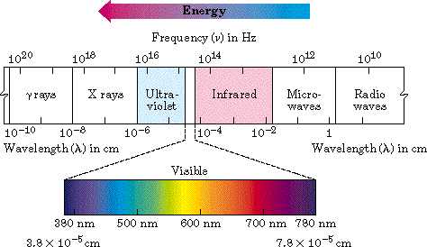The Electromagnetic Spectrum

Energy increases going to the left. The electromagnetic radiation interacts with the electromagnetic fields of the electrons to raise their energy levels from one state to the next. The nature of that interaction depends on the energy available. Ultraviolet and visible have sufficient energy to effect electronic transitions. Infrared has sufficient energy only to effect transitions between vibrational energy states. Microwave has only enough energy to effect transitions between rotationaly energy states. Thus the radiation absorbed tells us different information. Radio waves have insufficient energy to effect molecules but affect nuclear spin energy states found in magnetic fields. This latter interaction is most important because it is used in Nuclear Magnetic Resonance spectroscopy.

## NMR theory

1. All nuclei with unpaired protons or neutrons are magnetically active- they have a magnetic field

To lay a robust foundation for the Institute to reach its Zenith.

* + Achieving academic excellence through rigorous teaching, learning and evaluation practices.
  + To develop an ability to apply knowledge of basic science and Mathematics to excel in the field of Engineering.
  + To provide salutary environment for the betterment of faculty and the students.

arising from the unpaired nuclear particle. Of greatest interest to an organic chemist is hydrogen (including deuterium) and carbon ( the 13C isotope not the 12C isotope which has paired neutrons and protons).

1. Placed in an external magnetic field this magnetic field of the nucleus has two stable states, alignment with or against the applied field, which are of slightly different energies (aligned against is higher). The greater the applied field the greater this difference (this is a crucial fact).
2. Internal (in the molecule) factors which affect (add to or subtract from) the applied

magnetic field so as to put the individual nucleus in a different magnetic environment from that felt by another nucleus create differences in the nuclei.

1. Higher applied magnetic fields will create larger absolute numerical values of the differences between energy states and allow easier distinction between two different nuclei (better resolution).

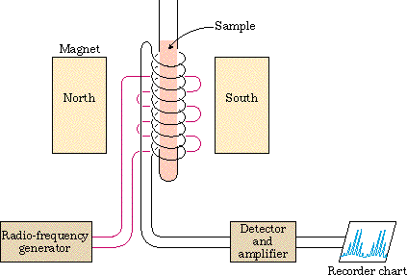A schematic of an NMR spectrometer

1. Electromagnetic radiation of radio frequency wavelengths is of the right energy range to cause the nucleus to move (resonate) between these two energy states. This absorption

allows detection of the hydrogen or carbon-13 nucleus. Different nuclei experiencing different

To lay a robust foundation for the Institute to reach its Zenith.

* + Achieving academic excellence through rigorous teaching, learning and evaluation practices.
  + To develop an ability to apply knowledge of basic science and Mathematics to excel in the field of Engineering.
  + To provide salutary environment for the betterment of faculty and the students.

magnetic fields and thus different energy differences between states will absorb different radio frequencies or at a particular constant frequency will absorb at different applied magnetic fields and allow us to distinguish between them.

This selectivity of energy required to match the energy differences between states is fundamental for all spectroscopies. The energy states are termed quantized. Transitions can occur only when the precise energy corresponding to the energy difference between the states is delivered to the system to excite it to the higher state. So the frequency (or wavelength) of radiation absorbed is specific to that energy transition. When the energy difference between

the states changes or is different, the frequency of light absorbed will change.

1. What internal magnetic factors modify the applied magnetic field to create the effective field experienced by the individual nuclei, thus changing the energy (frequency) needed for the transition (resonance)?

Two:

1. The electrons in the bonds around those nuclei.
2. The magnetic fields of neighboring nuclei.

Consider a. first.

The electrons act to oppose the applied field shielding the nuclei form it. Since every different type of hydrogen is an a different electronic environment, each type will experience a different effective magnetic field and thus a different resonance frequency. We can tell one type of nucleus from another type. We term this value the chemical shift. Chemical shift is expressed as a delta value.

delta = chemical shift (number of Hz away from standard TMS)/MHz of instrument For example, delta = 60 Hz/ 60,000,000 Hz = 1 ppm

The spectrum is presented as follows:

To lay a robust foundation for the Institute to reach its Zenith.

* Achieving academic excellence through rigorous teaching, learning and evaluation practices.
* To develop an ability to apply knowledge of basic science and Mathematics to excel in the field of Engineering.
* To provide salutary environment for the betterment of faculty and the students.

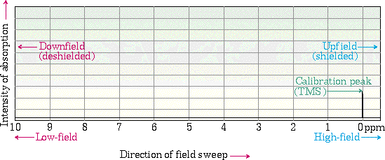

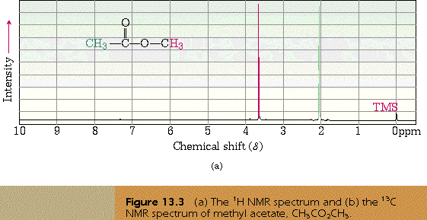Some simple spectra:

To lay a robust foundation for the Institute to reach its Zenith.

* Achieving academic excellence through rigorous teaching, learning and evaluation practices.
* To develop an ability to apply knowledge of basic science and Mathematics to excel in the field of Engineering.
* To provide salutary environment for the betterment of faculty and the students.

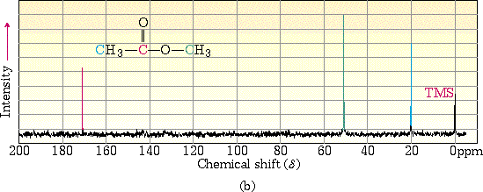

Note :

Two types of hydrogens, the hydrogens of a methyl are the same- they spin and experience the same average environment. The oxygen pulls electrons away from the right methyl and it is deshielded from the applied field, shifted downfield, a smaller field is needed to bring it into resonance. Three kinds of carbon. Note how deshielded the carbonyl carbon is.

Look at the chemical shift ranges. Very different for the different nuclei. TMS is tetramethylsilane and is chosen because all resonances are to the left of this peak so it’s handy to use as a standard set to zero.

Identical nuclei have the same chemical shift. If you have a hard time deciding if they are identical, imagine subsituting each with a halogen and ask if it would have the same name.

So chemical shifts are somewhat typical of particular types of hydrogen, predictable and useful for knowing what kind of group based on the chemical shift. See the table below. But beware. Due to deshielding substitutions, these values shift down quite a bit.

To lay a robust foundation for the Institute to reach its Zenith.

* Achieving academic excellence through rigorous teaching, learning and evaluation practices.
* To develop an ability to apply knowledge of basic science and Mathematics to excel in the field of Engineering.
* To provide salutary environment for the betterment of faculty and the students.

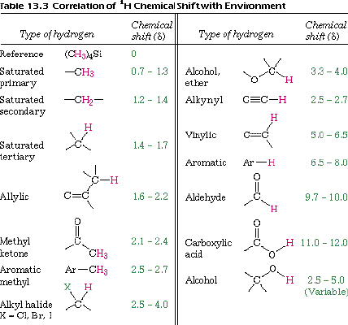

1. Integration Section 13.6- How many protons are producing this signal (integration does not work for carbon)

The area under the curve (correlates well with peak height) is proportional to the number of protons producing the signal. So the area is integrated in the calculus sense and compared for the different resonances. The ratio of the areas equals the ratio of the protons producing the signal. This

area is presented graphically by an integrating line in which the rise in the line as it passes through

the peak is proportional to the area under the peak. Note that it is proportional. The absolute values mean nothing, only the relative areas under the peak. If the number of hydrogens in the molecule are known then the total rise divided by the number of hydrogens gives a rise/hydrogen and

To lay a robust foundation for the Institute to reach its Zenith.

* + Achieving academic excellence through rigorous teaching, learning and evaluation practices.
  + To develop an ability to apply knowledge of basic science and Mathematics to excel in the field of Engineering.
  + To provide salutary environment for the betterment of faculty and the students.

dividing that value into the rise in a peak will give the number of hydrogens in the peak. If the total is not known, then some peak must be guessed and the other peaks surmised from the relative areas.

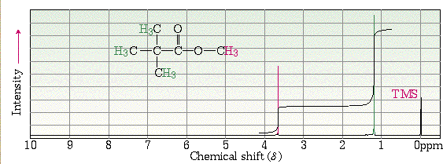

**E. Spin - spin splitting:** What’s next door - the best information from NMR

Since nuclei produce magnetic fields (the ones we’ve been talking about aligning with and against the field), those fields would affect the effective field felt by the hydrogen being measured. In the high energy state they would oppose (reduce) the field and in the low energy state reinforce (increase) the field.

Thus a neighboring hydrogen would cause another hydrogen to feel two fields effective field = applied field - electron shielding + or - neighboring nuclei field

So instead of seeing one signal, if a single neighboring hydrogen splits the signal you would see two, called a doublet. At first this seems a painful complication but it tells you that if you

see a doublet that nucleus has a single hydrogen adjacent. With such information you can put the pieces in order to make a structure.

Similarly, two neighboring nuclei yield three peaks, three yield four, etc. This is termed the n+1 rule stating that a signal will be split into n+1 peaks when n equivalent nuclei (hydrogens) are

To lay a robust foundation for the Institute to reach its Zenith.

* Achieving academic excellence through rigorous teaching, learning and evaluation practices.
* To develop an ability to apply knowledge of basic science and Mathematics to excel in the field of Engineering.
* To provide salutary environment for the betterment of faculty and the students.

adjacent. The peak areas are also predictable based on an analysis of the possible states and can be readily remembered by Paschal’s triangle.

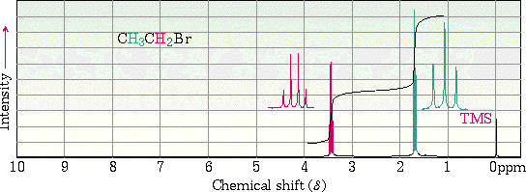

Note that the CH3 group is a triplet being split by the two neighboring hydrogens of the CH2. The CH2 group is a quartet being split by the three hydrogens of the CH3.

Now let’s see if you can predict the chemical shift and splitting pattern of isopropyl bromide.

So , the rules for splitting are:

1. Equivalent hydrogens do not split one another.
2. a.The signal of a type of hydrogen is split into n+1 peaks, where n=the number of equivalent neighboring hydrogens.

b. When two different types of hydrogen are adjacent, they split the signal independently to produce (na+1)(nb+1) peaks.

To lay a robust foundation for the Institute to reach its Zenith.

* Achieving academic excellence through rigorous teaching, learning and evaluation practices.
* To develop an ability to apply knowledge of basic science and Mathematics to excel in the field of Engineering.
* To provide salutary environment for the betterment of faculty and the students.

Consider this more complicated example.

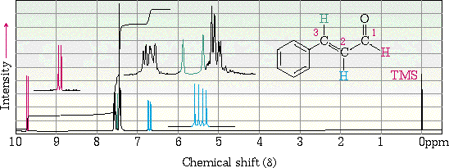

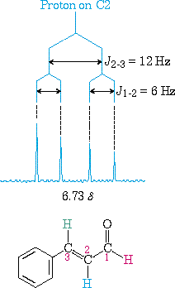

To lay a robust foundation for the Institute to reach its Zenith.

* Achieving academic excellence through rigorous teaching, learning and evaluation practices.
* To develop an ability to apply knowledge of basic science and Mathematics to excel in the field of Engineering.
* To provide salutary environment for the betterment of faculty and the students.

The amount by which the signal is split (the distance apart) is called J , the coupling constant but is not critical for our level of understanding. Hydrogens splitting each other have the same J value.

Aromatic regions are more complex because of the often very similar chemical shifts and small coupling constants and extensive overlaps of signals.

To lay a robust foundation for the Institute to reach its Zenith.

* Achieving academic excellence through rigorous teaching, learning and evaluation practices.
* To develop an ability to apply knowledge of basic science and Mathematics to excel in the field of Engineering.
* To provide salutary environment for the betterment of faculty and the students.

# UV-Spectroscopy

Absorption of ultraviolet (UV) and visible radiation is one of the most routinely used analytical tools in life sciences research. The simplest application of UV/Visible radiation is to quantify the amount of a substance present in a solution.

UV region of electromagnetic radiation encompasses the wavelengths ranging from

~100 nm – ~400 nm while visible region encompasses the wavelengths from ~400 nm

* ~780 nm. For the sake of convenience in discussing the observations, UV region is loosely divided into near UV (wavelength region nearer to the visible region, λ ~ 250 nm – 400 nm), far UV region (wavelength region farther to the visible region, λ ~ 190 nm – 250 nm) and vacuum UV region (λ< 190 nm).

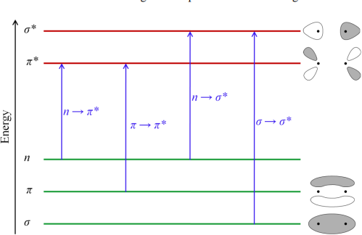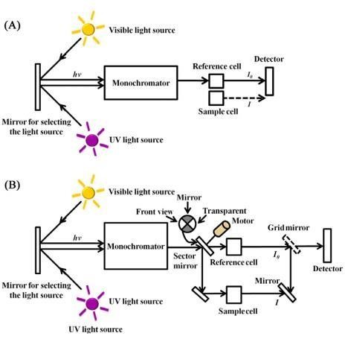

To lay a robust foundation for the Institute to reach its Zenith.

* + Achieving academic excellence through rigorous teaching, learning and evaluation practices.
  + To develop an ability to apply knowledge of basic science and Mathematics to excel in the field of Engineering.
  + To provide salutary environment for the betterment of faculty and the students.

1. Spin selection rule (△S = 0 for the transition to be allowed): there should be no change in spin orientation i. e no spin inversion takes place during these transitions. Thus, S→S, T→T are allowed, but S→T, T→S are forbidden transitions.
2. Laporte (orbital) selection rule (Δl = ±1): • If the molecule has a centre of symmetry, transitions within a given set of p- or d-orbitals (i.e. those which only involve a redistribution of electrons within a given subshell) are forbidden. There must be a change in the parity (symmetry), i. e transition can occur only between states of opposite parity.

Laporte - allowed transitions: g → u or u → g Laporte - forbidden transitions: g → g or u → u

g stands for gerade – compound with a center of symmetry. u stands for ungerade – compound without a center of symmetry.

Thus, s → p, p → d are allowed, but s → s, p → p are forbidden.

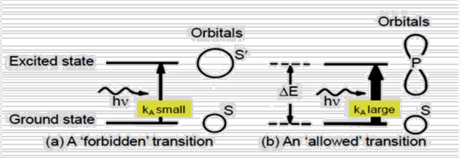

To lay a robust foundation for the Institute to reach its Zenith.

* + Achieving academic excellence through rigorous teaching, learning and evaluation practices.
  + To develop an ability to apply knowledge of basic science and Mathematics to excel in the field of Engineering.
  + To provide salutary environment for the betterment of faculty and the students.

**Applications of UV Spectroscopy**

1. **Detection of Impurities**
   * + It is one of the best methods for determination of impurities in organic molecules.
     + Additional peaks can be observed due to impurities in the sample and it can be compared with that of standard raw material.
     + By also measuring the absorbance at specific wavelength, the impurities can be detected.
2. **Structure elucidation of organic compounds**
   * + It is useful in the structure elucidation of organic molecules, such as in detecting the presence or absence of unsaturation, the presence of hetero atoms.
3. UV absorption spectroscopy can be used for the quantitative determination of compounds that absorb UV radiation.
4. UV absorption spectroscopy can characterize those types of compounds which absorbs UV radiation thus used in qualitative determination of compounds.

Identification is done by comparing the absorption spectrum with the spectra of known compounds.

1. This technique is used to detect the presence or absence of functional group in the compound.
2. Kinetics of reaction can also be studied using UV spectroscopy.
3. Many drugs are either in the form of raw material or in the form of formulation. They can be assayed by making a suitable solution of the drug in a solvent and measuring the absorbance at specific wavelength.

To lay a robust foundation for the Institute to reach its Zenith.

* + Achieving academic excellence through rigorous teaching, learning and evaluation practices.
  + To develop an ability to apply knowledge of basic science and Mathematics to excel in the field of Engineering.
  + To provide salutary environment for the betterment of faculty and the students.

**Fluorescence:** Fluorescence, emission of electromagnetic radiation, usually visible light, caused by excitation of atoms in a material, which then reemit almost immediately (within about 10−8 seconds). The initial excitation is usually caused by absorption of energy from incident radiation or particles, such as X-rays or electrons.

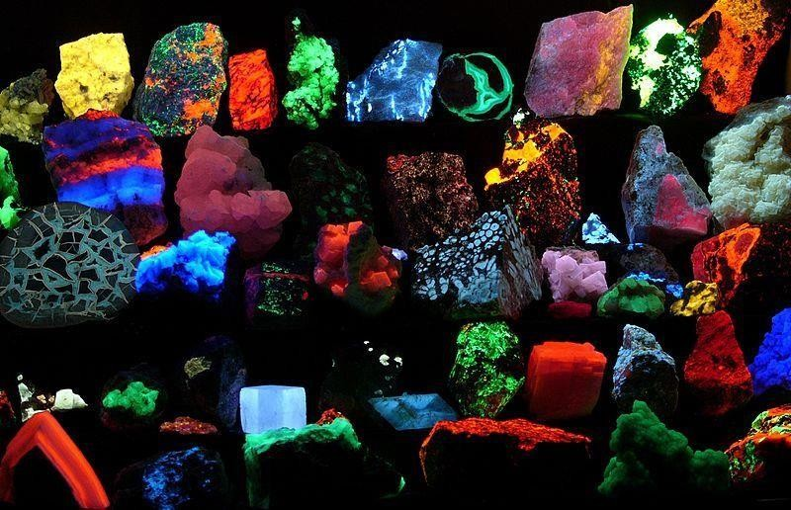

Fluorescence spectroscopy is an emerging diagnostic tool for various medical diseases including premalignant and malignant lesions. Fluorescence spectroscopy is a noninvasive technique and has been applied successfully for the diagnosis of multisystem cancers with high sensitivity and specificity